**Task 1:**

lmf1<-lm(dat$Heel.Cracks~dat$Power+dat$Time+dat$Pressure+dat$LoopValue)

Call:

lm(formula = dat$Heel.Cracks ~ dat$Power + dat$Time + dat$Pressure +

dat$LoopValue)

Residuals:

Min 1Q Median 3Q Max

-0.11651 -0.06983 -0.03391 0.03963 0.26039

Coefficients:

Estimate Std. Error t value Pr(>|t|)

(Intercept) -0.9532375 0.2183215 -4.366 0.000332 ***

dat$Power 0.0059075 0.0008804 6.710 2.05e-06 ***

dat$Time 0.0016027 0.0008477 1.891 0.074002 .

dat$Pressure 0.0003308 0.0002527 1.309 0.206204

dat$LoopValue 0.0007357 0.0012317 0.597 0.557359

---

Signif. codes: 0 ‘***’ 0.001 ‘**’ 0.01 ‘*’ 0.05 ‘.’ 0.1 ‘ ’ 1

Residual standard error: 0.1069 on 19 degrees of freedom

Multiple R-squared: 0.719, Adjusted R-squared: 0.6598

F-statistic: 12.15 on 4 and 19 DF, p-value: 4.535e-05

lmf2<-lm(dat$Liftoff~dat$Power+dat$Time+dat$Pressure+dat$LoopValue)

Call:

lm(formula = dat$Liftoff ~ dat$Power + dat$Time + dat$Pressure +

dat$LoopValue)

Residuals:

Min 1Q Median 3Q Max

-0.216868 -0.136880 -0.001868 0.120038 0.233045

Coefficients:

Estimate Std. Error t value Pr(>|t|)

(Intercept) 0.9682748 0.3222206 3.005 0.00728 **

dat$Power -0.0081727 0.0012994 -6.290 4.88e-06 ***

dat$Time -0.0020621 0.0012511 -1.648 0.11574

dat$Pressure 0.0005915 0.0003730 1.586 0.12927

dat$LoopValue 0.0026860 0.0018178 1.478 0.15590

---

Signif. codes: 0 ‘***’ 0.001 ‘**’ 0.01 ‘*’ 0.05 ‘.’ 0.1 ‘ ’ 1

Residual standard error: 0.1577 on 19 degrees of freedom

Multiple R-squared: 0.7138, Adjusted R-squared: 0.6535

F-statistic: 11.84 on 4 and 19 DF, p-value: 5.37e-05

lmf3<-lm(dat$WireTear~dat$Power+dat$Time+dat$Pressure+dat$LoopValue)

Call:

lm(formula = dat$WireTear ~ dat$Power + dat$Time + dat$Pressure +

dat$LoopValue)

Residuals:

Min 1Q Median 3Q Max

-0.33238 -0.21092 0.00429 0.15177 0.30429

Coefficients:

Estimate Std. Error t value Pr(>|t|)

(Intercept) 0.9644860 0.4538226 2.125 0.0469 *

dat$Power 0.0023627 0.0018300 1.291 0.2122

dat$Time 0.0005458 0.0017620 0.310 0.7601

dat$Pressure -0.0009279 0.0005253 -1.766 0.0934 .

dat$LoopValue -0.0034432 0.0025602 -1.345 0.1945

---

Signif. codes: 0 ‘***’ 0.001 ‘**’ 0.01 ‘*’ 0.05 ‘.’ 0.1 ‘ ’ 1

Residual standard error: 0.2221 on 19 degrees of freedom

Multiple R-squared: 0.275, Adjusted R-squared: 0.1224

F-statistic: 1.802 on 4 and 19 DF, p-value: 0.1702

**Lmf1**

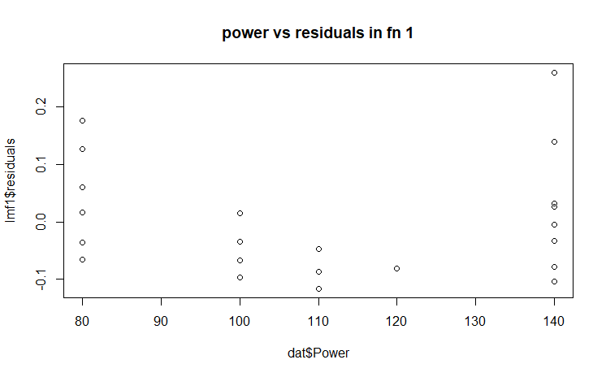

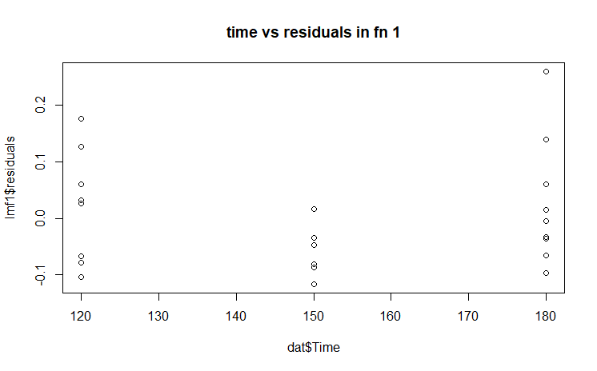

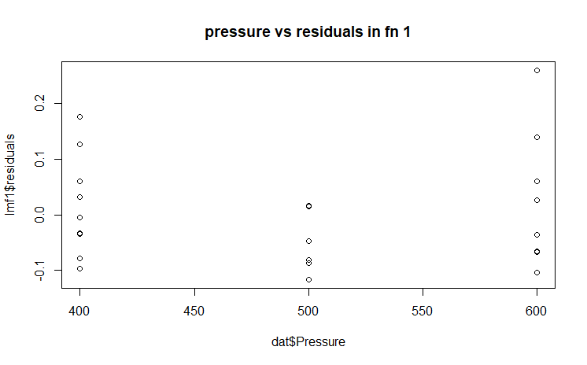

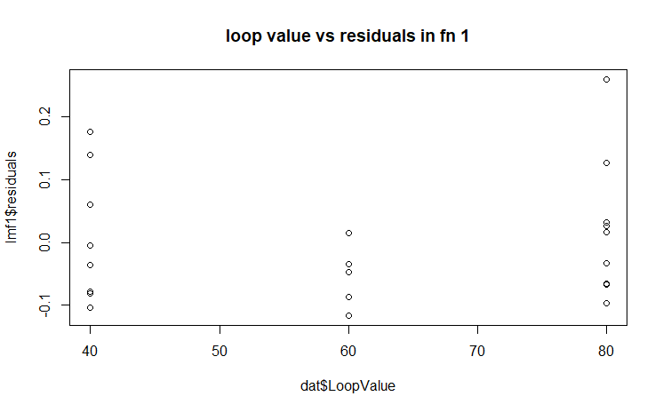

Plots for lmf2

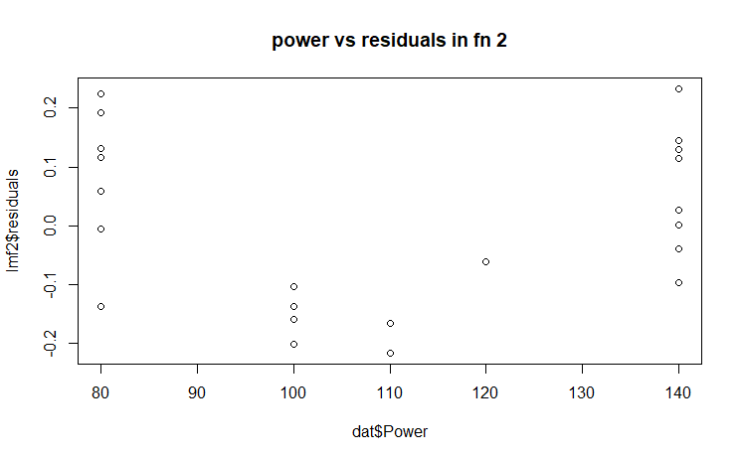

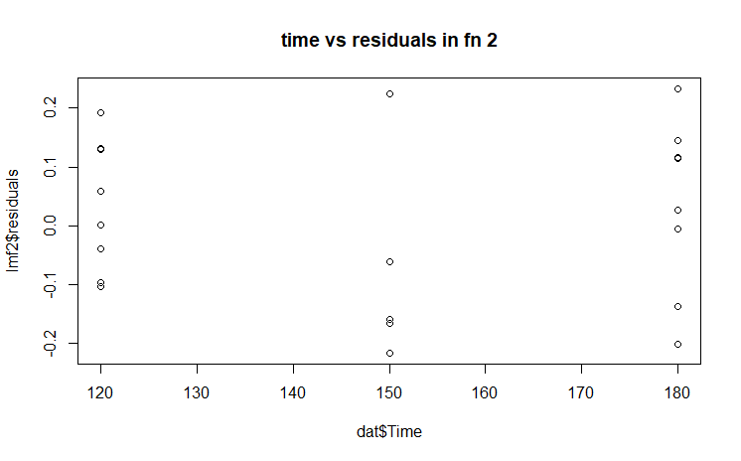

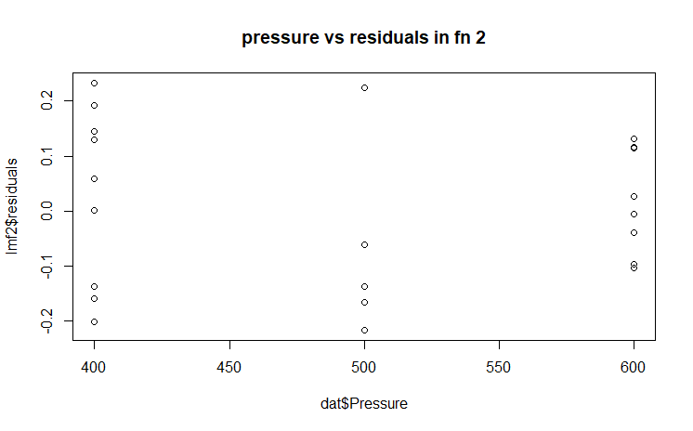

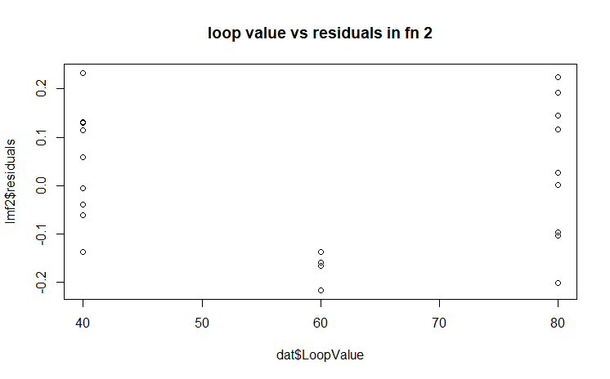

**Plots for lmf3**

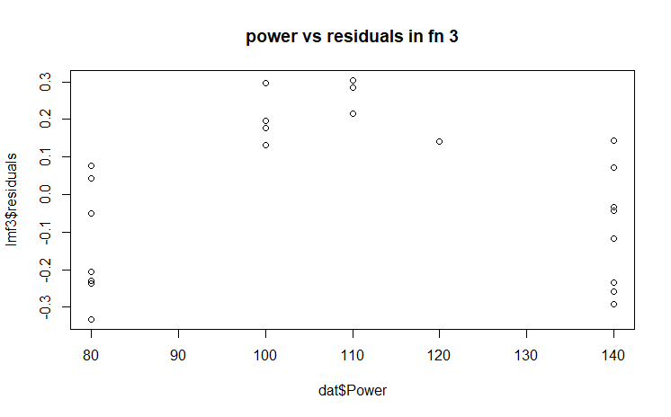

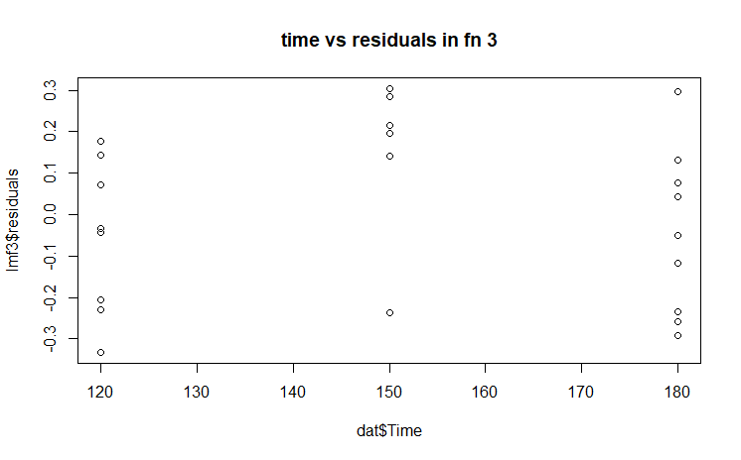

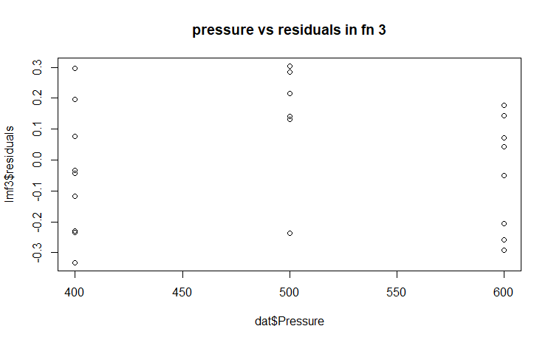

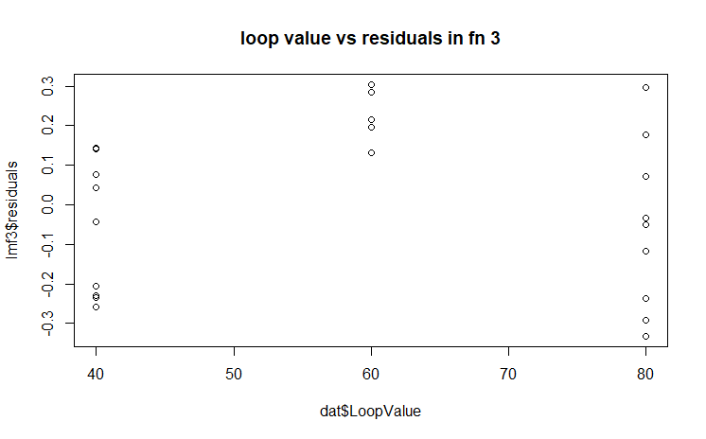

**TASK 2**

sqfm1<-lm(dat$Heel.Cracks~dat$Power+dat$Time+dat$Pressure+dat$LoopValue+I(dat$Power^2)+I(dat$Time^2)+I(dat$Pressure^2)+I(dat$LoopValue^2))

summary(sqfm1)

Call:

lm(formula = dat$Heel.Cracks ~ dat$Power + dat$Time + dat$Pressure +

dat$LoopValue + I(dat$Power^2) + I(dat$Time^2) + I(dat$Pressure^2) +

I(dat$LoopValue^2))

Residuals:

Min 1Q Median 3Q Max

-0.125672 -0.053590 -0.002656 0.026173 0.233306

Coefficients:

Estimate Std. Error t value Pr(>|t|)

(Intercept) 8.929e-01 1.433e+00 0.623 0.542

dat$Power -2.501e-02 1.906e-02 -1.312 0.209

dat$Time -1.207e-02 2.825e-02 -0.427 0.675

dat$Pressure 1.819e-03 8.366e-03 0.217 0.831

dat$LoopValue 1.614e-02 2.590e-02 0.623 0.542

I(dat$Power^2) 1.399e-04 8.651e-05 1.617 0.127

I(dat$Time^2) 4.541e-05 9.363e-05 0.485 0.635

I(dat$Pressure^2) -1.548e-06 8.403e-06 -0.184 0.856

I(dat$LoopValue^2) -1.266e-04 2.148e-04 -0.590 0.564

Residual standard error: 0.1032 on 15 degrees of freedom

Multiple R-squared: 0.7929, Adjusted R-squared: 0.6824

F-statistic: 7.178 on 8 and 15 DF, p-value: 0.0005749

sqfm2<-lm(dat$Liftoff ~dat$Power+dat$Time+dat$Pressure+dat$LoopValue+I(dat$Power^2)+I(dat$Time^2)+I(dat$Pressure^2)+I(dat$LoopValue^2))

summary(sqfm2)

Call:

lm(formula = dat$Liftoff ~ dat$Power + dat$Time + dat$Pressure +

dat$LoopValue + I(dat$Power^2) + I(dat$Time^2) + I(dat$Pressure^2) +

I(dat$LoopValue^2))

Residuals:

Min 1Q Median 3Q Max

-0.22660 -0.05523 0.01473 0.05398 0.15605

Coefficients:

Estimate Std. Error t value Pr(>|t|)

(Intercept) 2.335e+00 1.441e+00 1.621 0.12584

dat$Power -7.315e-02 1.917e-02 -3.816 0.00169 **

dat$Time 1.131e-02 2.841e-02 0.398 0.69616

dat$Pressure 7.723e-03 8.414e-03 0.918 0.37321

dat$LoopValue -2.126e-02 2.605e-02 -0.816 0.42718

I(dat$Power^2) 2.944e-04 8.701e-05 3.384 0.00409 **

I(dat$Time^2) -4.393e-05 9.417e-05 -0.467 0.64754

I(dat$Pressure^2) -7.296e-06 8.451e-06 -0.863 0.40156

I(dat$LoopValue^2) 2.033e-04 2.160e-04 0.941 0.36170

---

Signif. codes: 0 ‘***’ 0.001 ‘**’ 0.01 ‘*’ 0.05 ‘.’ 0.1 ‘ ’ 1

Residual standard error: 0.1038 on 15 degrees of freedom

Multiple R-squared: 0.902, Adjusted R-squared: 0.8498

F-statistic: 17.27 on 8 and 15 DF, p-value: 2.919e-06

sqfm3<-lm(dat$WireTear ~dat$Power+dat$Time+dat$Pressure+dat$LoopValue+I(dat$Power^2)+I(dat$Time^2)+I(dat$Pressure^2)+I(dat$LoopValue^2))

summary(sqfm3)

Call:

lm(formula = dat$WireTear ~ dat$Power + dat$Time + dat$Pressure +

dat$LoopValue + I(dat$Power^2) + I(dat$Time^2) + I(dat$Pressure^2) +

I(dat$LoopValue^2))

Residuals:

Min 1Q Median 3Q Max

-0.200932 -0.085977 -0.000113 0.076596 0.206952

Coefficients:

Estimate Std. Error t value Pr(>|t|)

(Intercept) -2.298e+00 2.056e+00 -1.117 0.28137

dat$Power 9.883e-02 2.735e-02 3.613 0.00256 **

dat$Time -4.686e-04 4.054e-02 -0.012 0.99093

dat$Pressure -9.111e-03 1.201e-02 -0.759 0.45974

dat$LoopValue 5.460e-03 3.717e-02 0.147 0.88517

I(dat$Power^2) -4.369e-04 1.242e-04 -3.518 0.00310 **

I(dat$Time^2) 2.879e-06 1.344e-04 0.021 0.98319

I(dat$Pressure^2) 8.408e-06 1.206e-05 0.697 0.49640

I(dat$LoopValue^2) -7.971e-05 3.083e-04 -0.259 0.79953

---

Signif. codes: 0 ‘***’ 0.001 ‘**’ 0.01 ‘*’ 0.05 ‘.’ 0.1 ‘ ’ 1

Residual standard error: 0.1482 on 15 degrees of freedom

Multiple R-squared: 0.7453, Adjusted R-squared: 0.6094

F-statistic: 5.485 on 8 and 15 DF, p-value: 0.002322

**Center point alarm:** you mentioned something like this in class once, I am not sure if it is correct, I might be mistaken.

In the graph plot of residuals vs fitted values for a linear model, if the observations follow this pattern

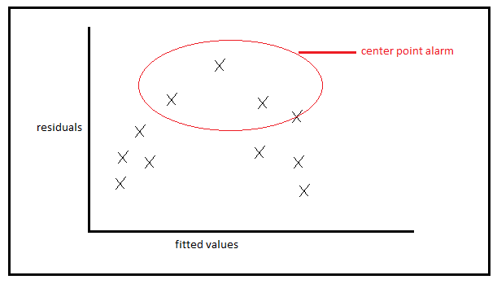

This means the residuals are not evenly distributed like they should be for error values to occur independently. But as we see a pattern here among the the points plotted, we must introduce a square term to the model. I have introduced square term in the answers below and plotted the plots for both cases (plots that show center point alarm vs the plots obtained after introduction of square term that show dispersed residuals) and displayed side by side for comparison.

**Comparing whether introduction of square term improves the model corresponding to component vs residual plot**

For function 3: wire tear in power component

|  |  |
| --- | --- |
| Before introducing sq term | After introducing sq term |
|  |  |

For function 3: wire tear in time component

|  |  |
| --- | --- |
| Before introducing sq term | After introducing sq term |
|  |  |

For function 3: wire tear in pressure component

|  |  |
| --- | --- |
| Before introducing sq term | After introducing sq term |
|  |  |

For function 3: wire tear in loop value component

|  |  |
| --- | --- |
| Before introducing sq term | After introducing sq term |
|  |  |

**Residuals vs fitted values plot for square models**

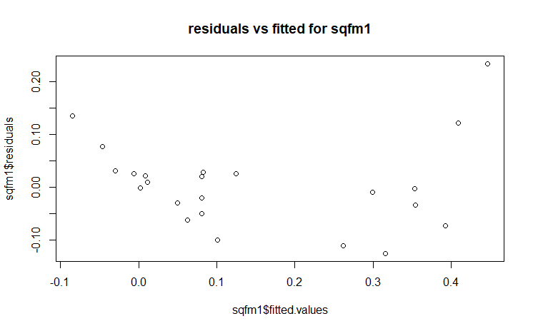

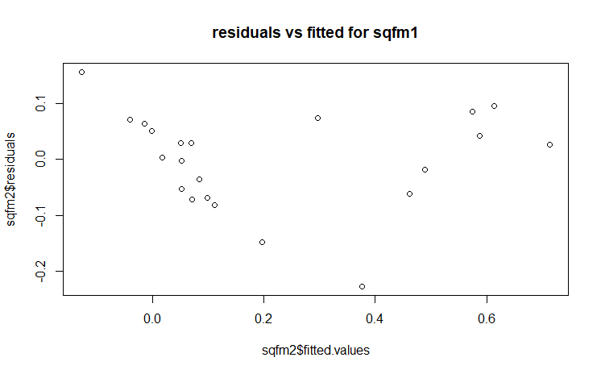

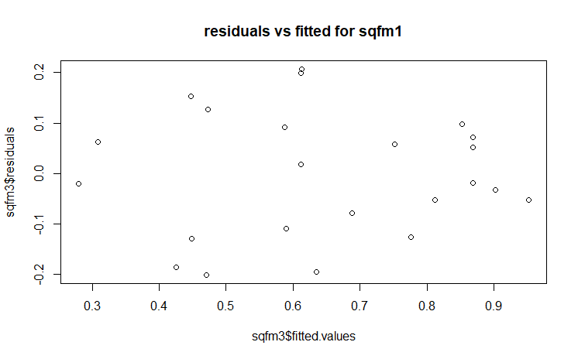

**TASK 4**

|  |  |  |  |  |
| --- | --- | --- | --- | --- |
|  |  | heelcracks |  |  |
|  |  | low(0-0.2) | high(0.2-1) | total |
| power | low(80-100) | 12 | 0 | 12 |
|  | high(120-140) | 3 | 6 | 9 |
|  | total | 15 | 6 | 21 |

Pr=15/21 * 100= 0.71

|  |  |  |  |  |
| --- | --- | --- | --- | --- |
|  |  | heelcracks | s=0.1 |  |
|  |  | low(0-0.1) | high(0.1-1) | total |
| power | low(80-100) | 11 | 1 | 12 |
|  | high(120-140) | 0 | 9 | 9 |
|  | total | 11 | 10 | 21 |

Pr=0.52

|  |  |  |  |  |
| --- | --- | --- | --- | --- |
|  |  | heelcracks | s=0.3 |  |
|  |  | low(0-0.3) | high(0.3-1) | total |
| power | low(80-100) | 12 | 0 | 12 |
|  | high(120-140) | 4 | 5 | 9 |
|  | total | 16 | 5 | 21 |

Pr=0.76

|  |  |  |  |  |
| --- | --- | --- | --- | --- |
|  |  | heelcracks | s=0.4 |  |
|  |  | low(0-0.4) | high(0.4-1) | total |
| power | low(80-100) | 12 | 0 | 12 |
|  | high(120-140) | 7 | 2 | 9 |
|  | total | 19 | 2 | 21 |

Pr=0.90

**Table of cutting point with sensitivity and specificity**

|  |  |  |  |
| --- | --- | --- | --- |
| **Cutting point** | **Sensitivity** | **specificity** | **1-specificity** |
| 0.1 | 1 | 0.9 | 0.1 |
| 0.2 | 0.8 | 1 | 0 |
| 0.3 | 0.75 | 1 | 0 |
| 0.4 | 0.63 | 1 | 0 |

